Steps to creating the project template used in this tutorial
These are the steps involved in creating the project template used in this tutorial

Create new project template
To create a new project template, go to Resource Console. In the Resource Console, click the Project templates category, and under the template list, click Create new.
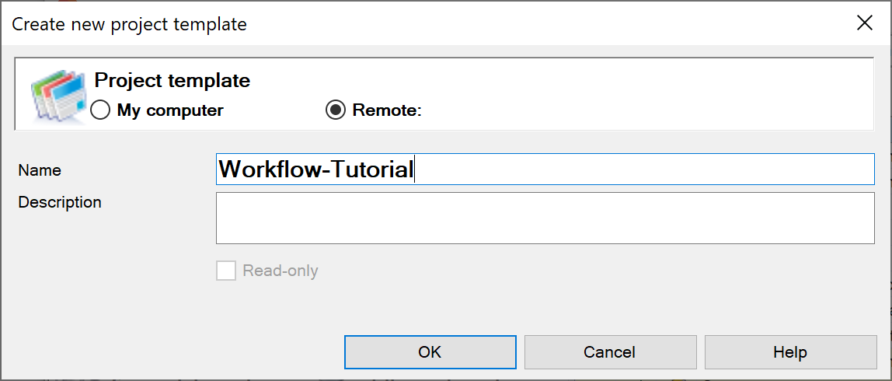
Type “Workflow-Tutorial” as the name and select Remote to create the template on your memoQ server.
Click OK.
This will create a project template.

Edit project template
Select the project template you have just created.
Click Edit.
If you need to edit one of the default project templates which come installed with memoQ, clone it first.

Pre-defined lists
To create a pre-defined client list, select the icon next to the Client text box.
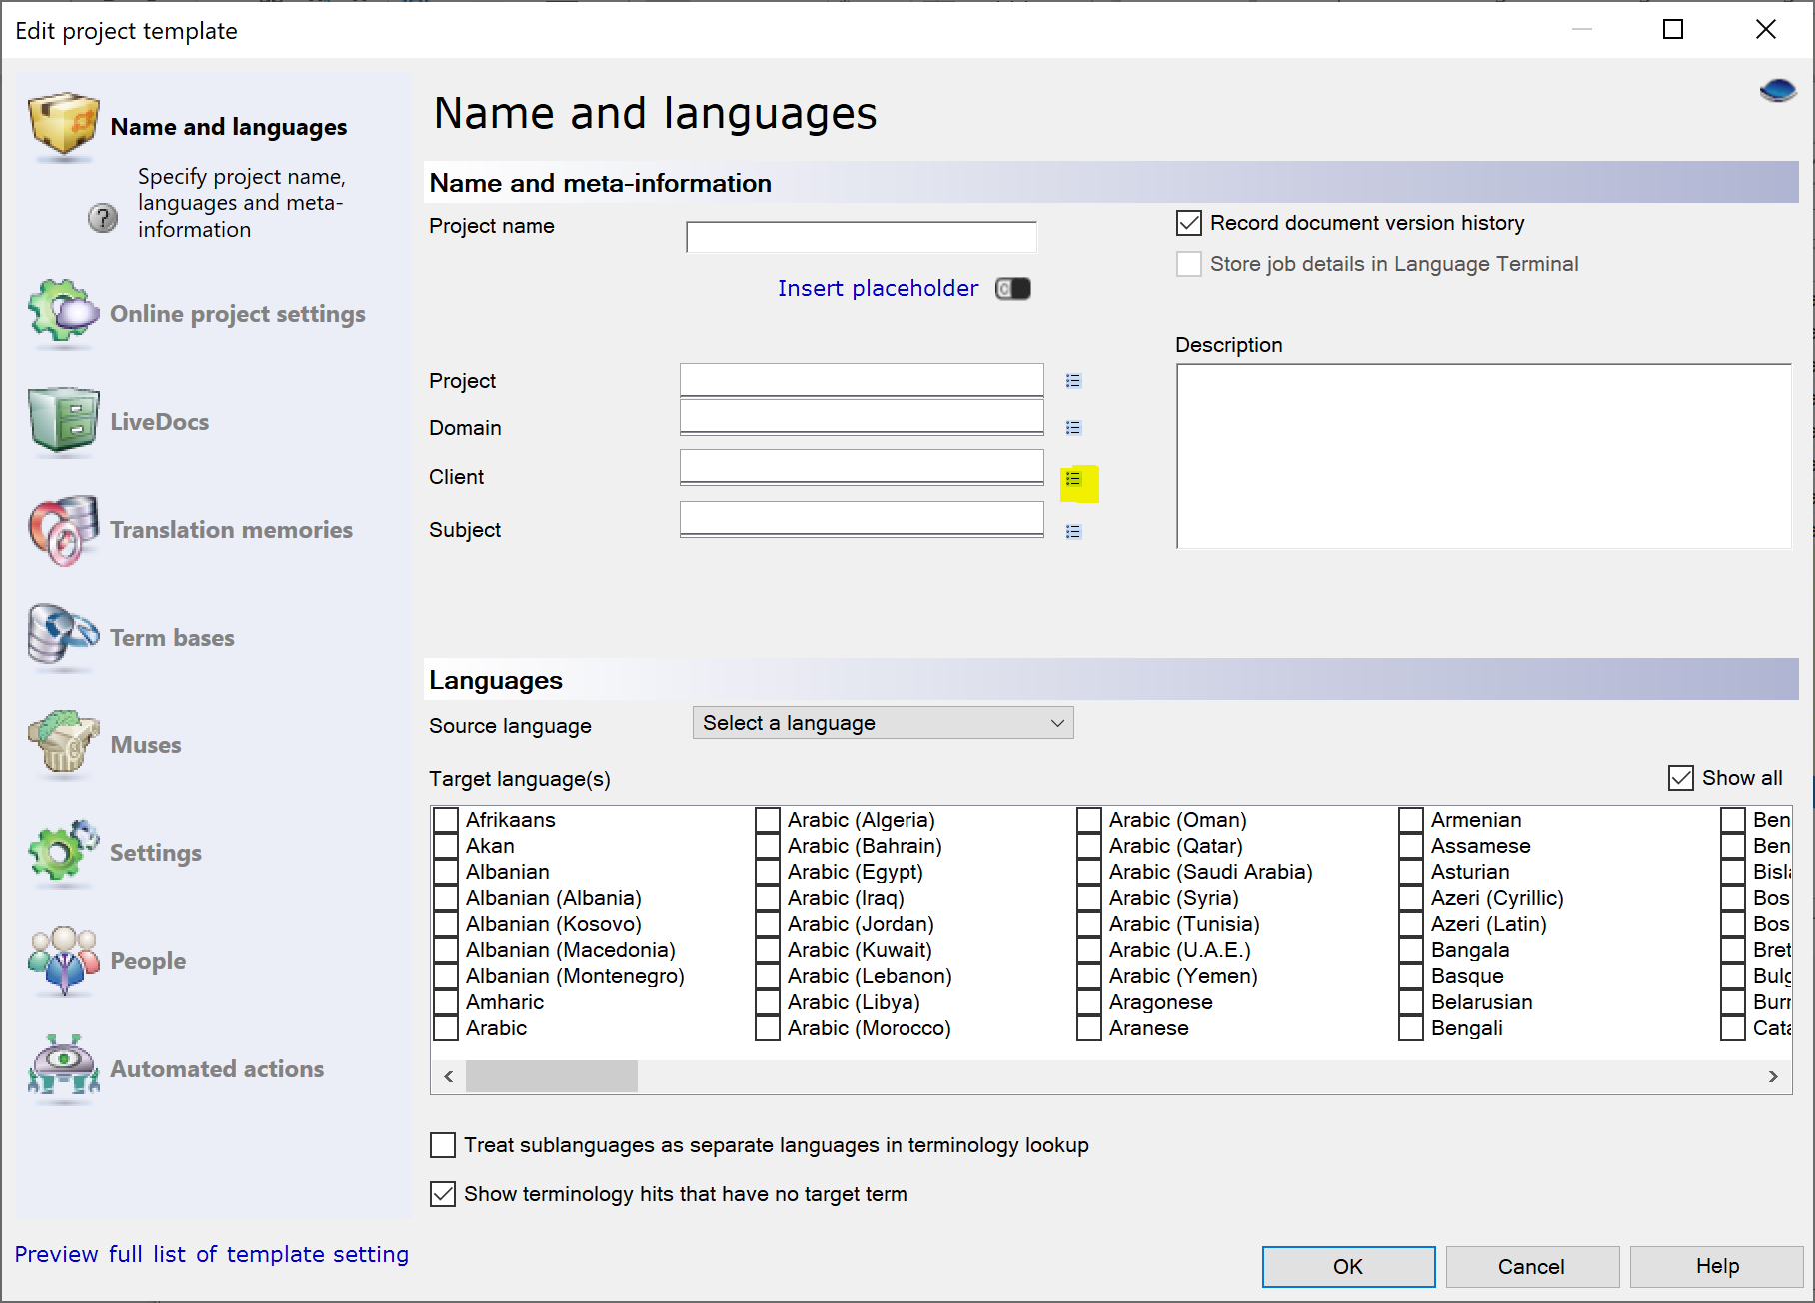
This will open a dialog where you can add items to a pre-defined list.
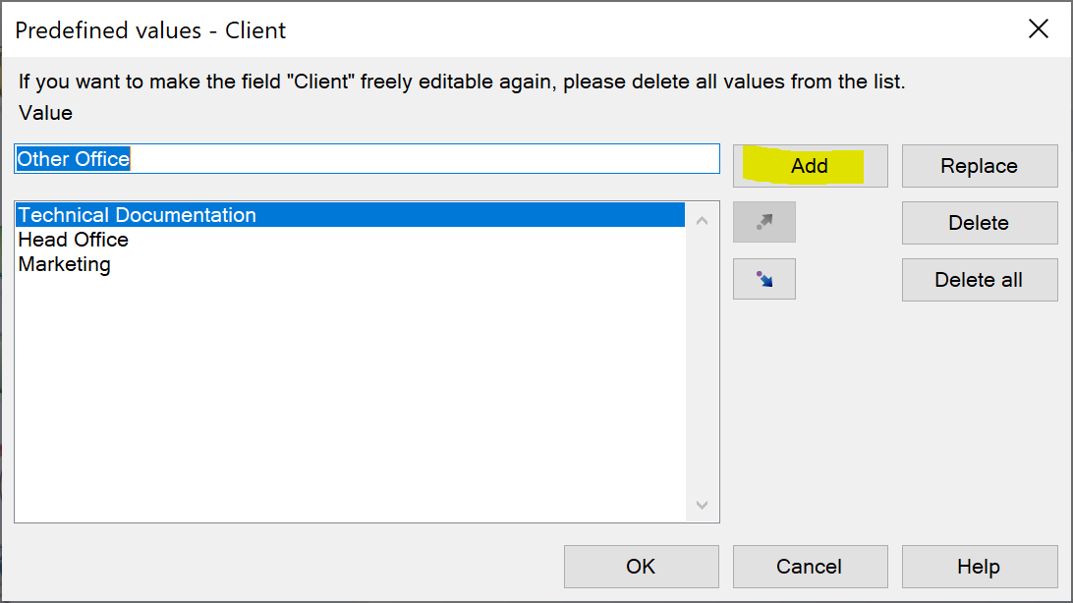
Type the text in the Value text box, and click Add.
Add the following to the Client pre-defined list: Marketing, Technical Documentation, Head Office, Other Office. Click OK.
Add the following to the Domain pre-defined list: Software, User Assistance, Marketing, Administration, Ad Hoc. Click OK.

Placeholders
We want to enforce a naming convention for the name of the project.
Place the cursor at the start of the Project name text box.
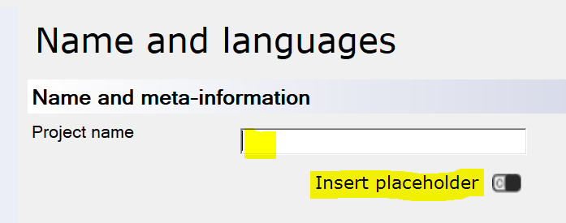
Click the Insert placeholder link.
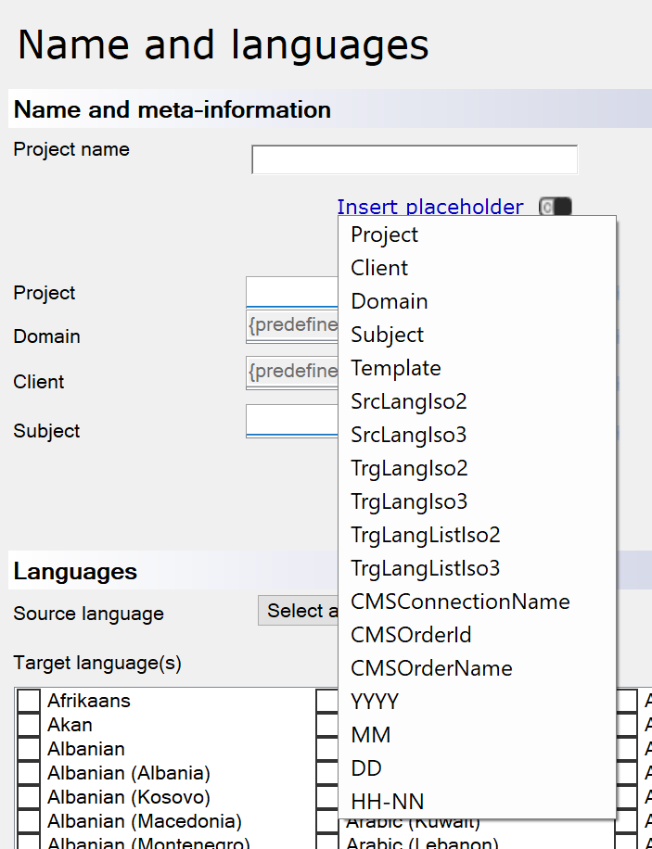
You will see a list of placeholders.
Select Client, then Domain, Subject, Date (DD), Month (MM), and Year (YYYY).
{Client}-{Domain}-{Subject}-{DD}-{MM}-{YYYY}-

Remove the final hyphen after (YYYY).

Translation memory and other resources
Go to the Translation memories tab. We are again going to use placeholders to enforce a naming convention.
In the name of the working TM, type “Working-“
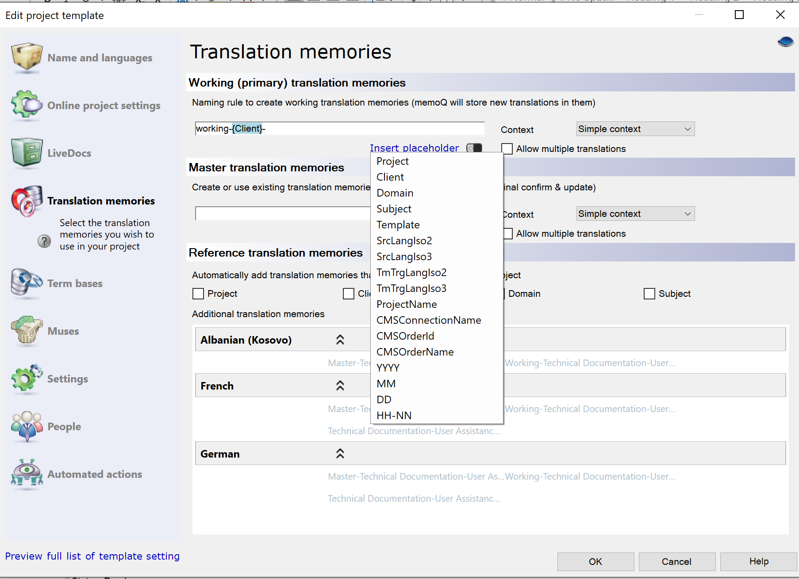
Then, using the placeholders, add Client, Domain, SrcLangIso2, and TmTrgLangIso2.
Remove the final hyphen.
working-{Client}-{Domain}-{SrcLangIso2}-{TmTrgLangIso2}
Copy and paste this into the Master translation memories text box. Delete the word “working”, and add “master”.
Under Reference translation memories, select Client and Domain.

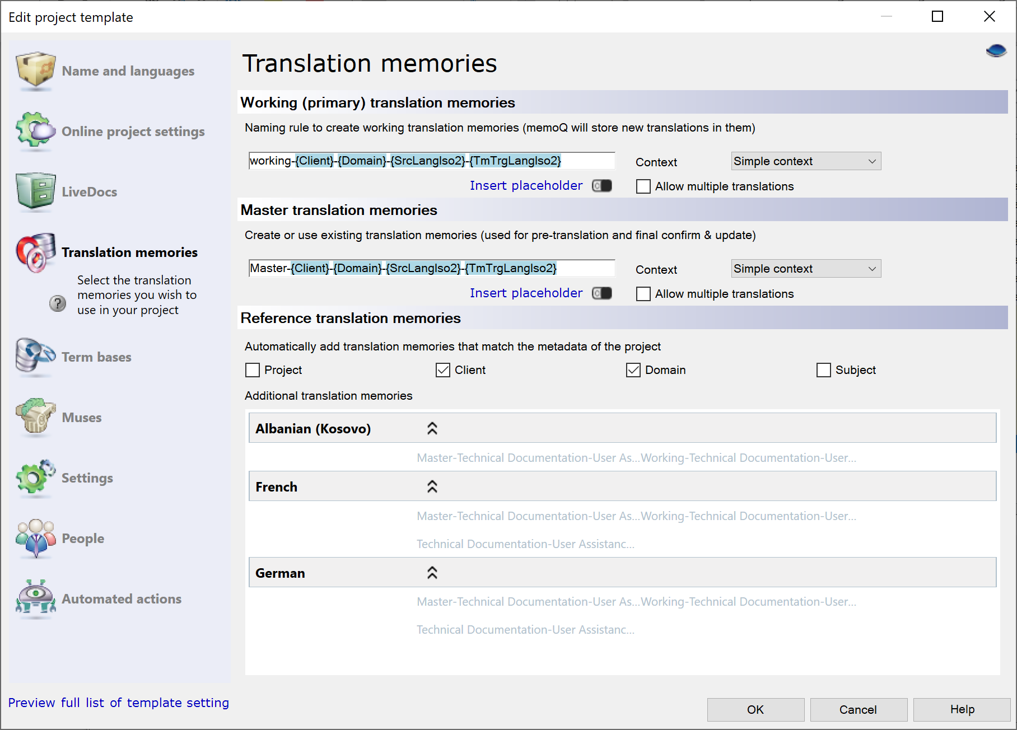

For term bases, add the placeholders Client and Domain, and under Automatically add term bases..., select Domain.
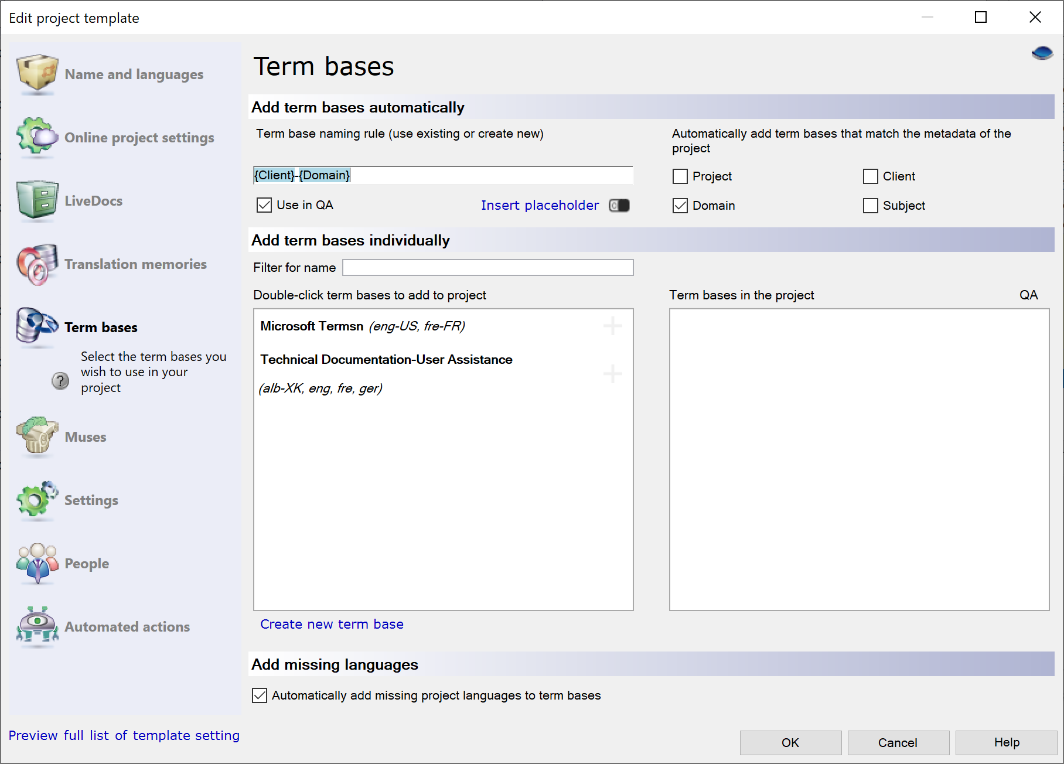

Do the same for LiveDocs.
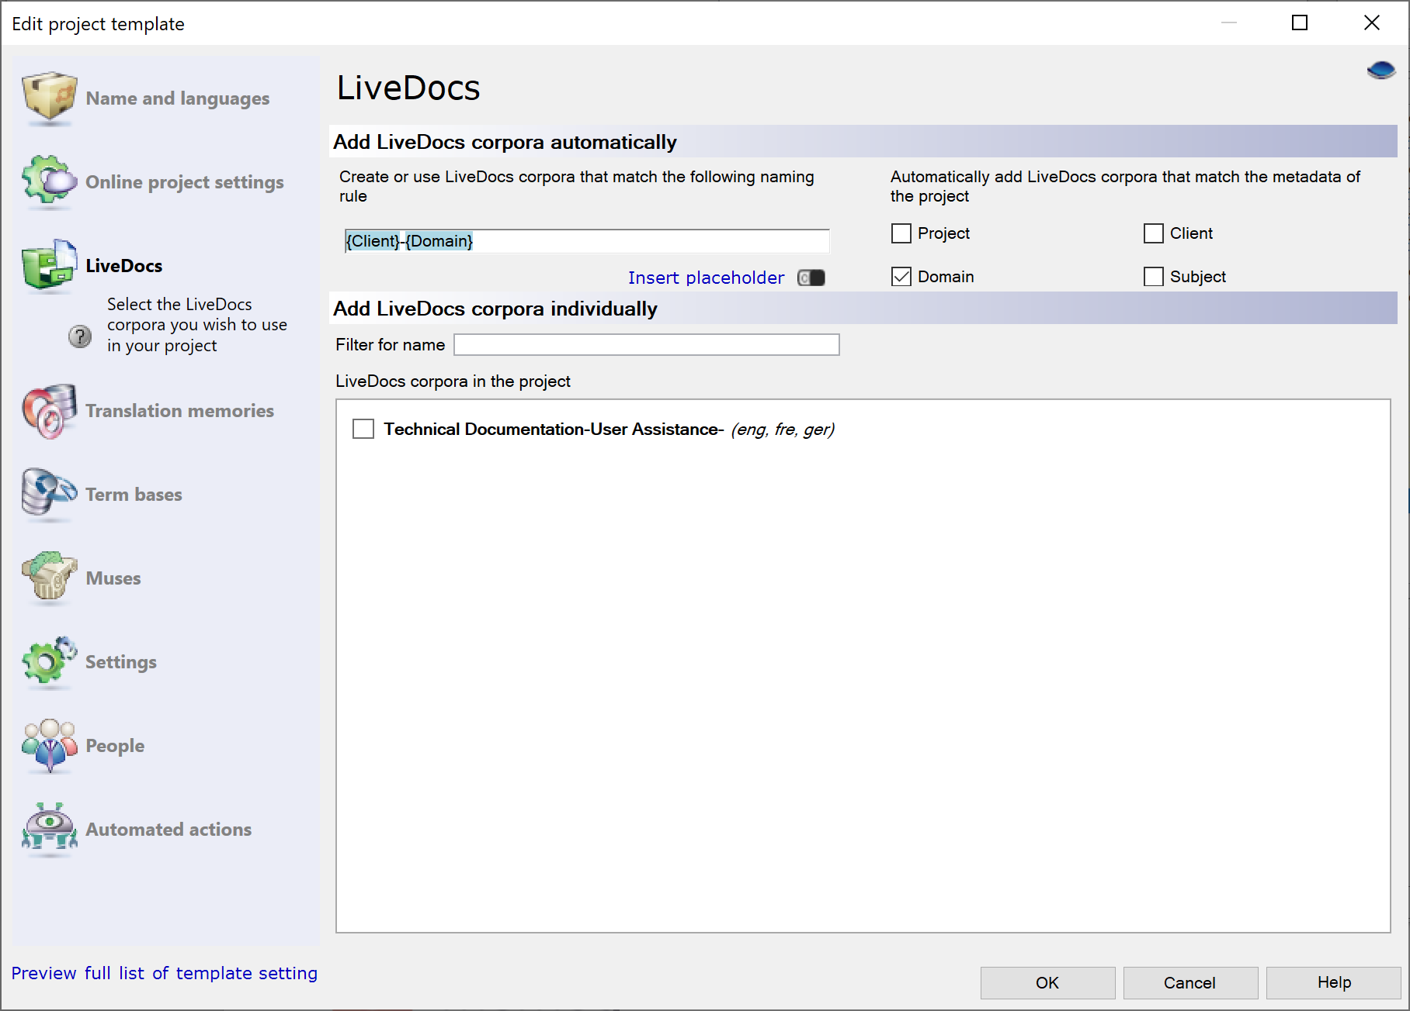

Automated Actions
For this template, we do the following:
Trigger | Action
After Document Import | Create analysis report
After Document Import | Pre-translate
Translator delivers document | Export table RTF on server
Document completes workflow | Run QA and export report to server

Select the After document report trigger. Click on the + button to the right of the Action column.
Choose Create analysis report from the list of actions. Click Add.
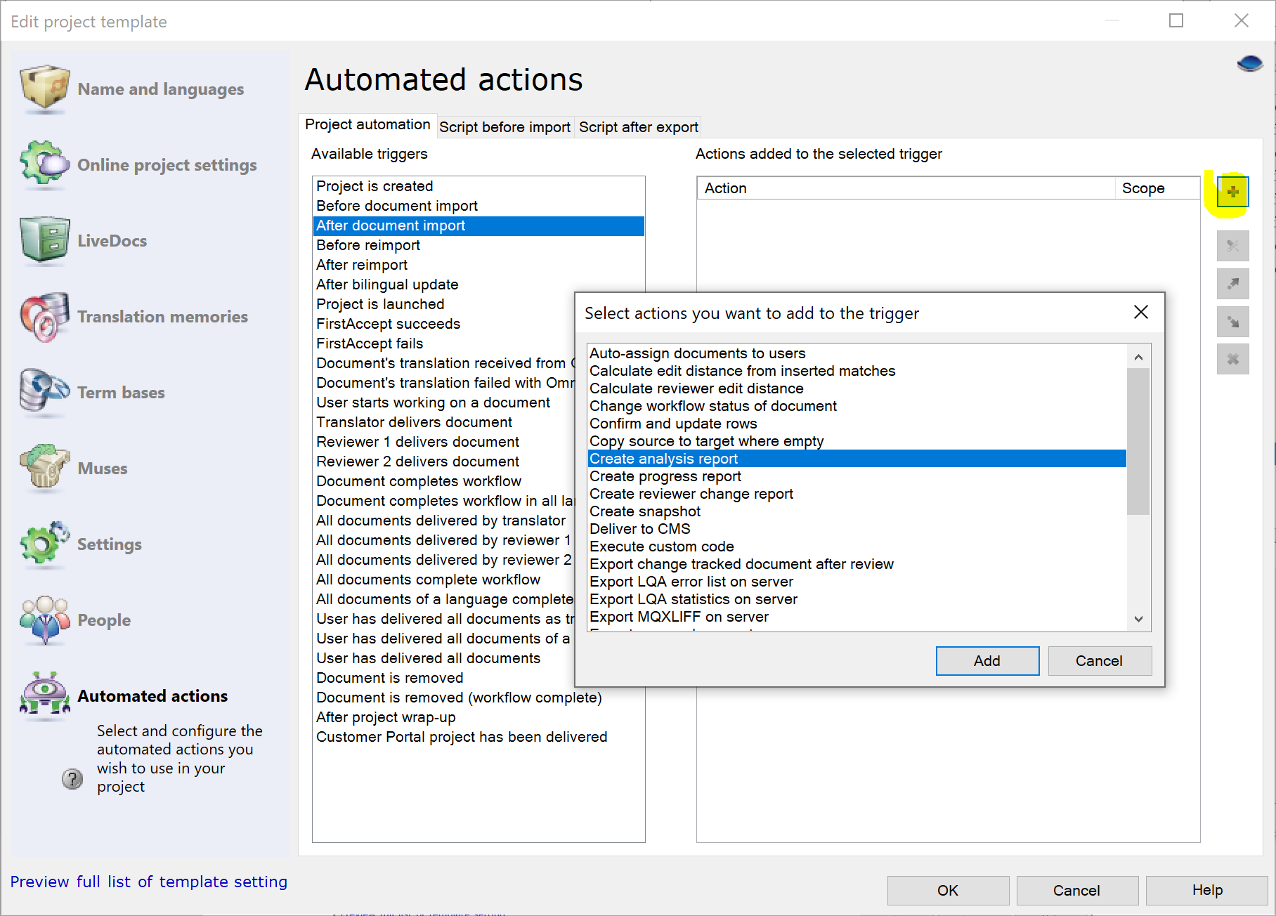
Change the options for the analysis report if needed, and click OK.
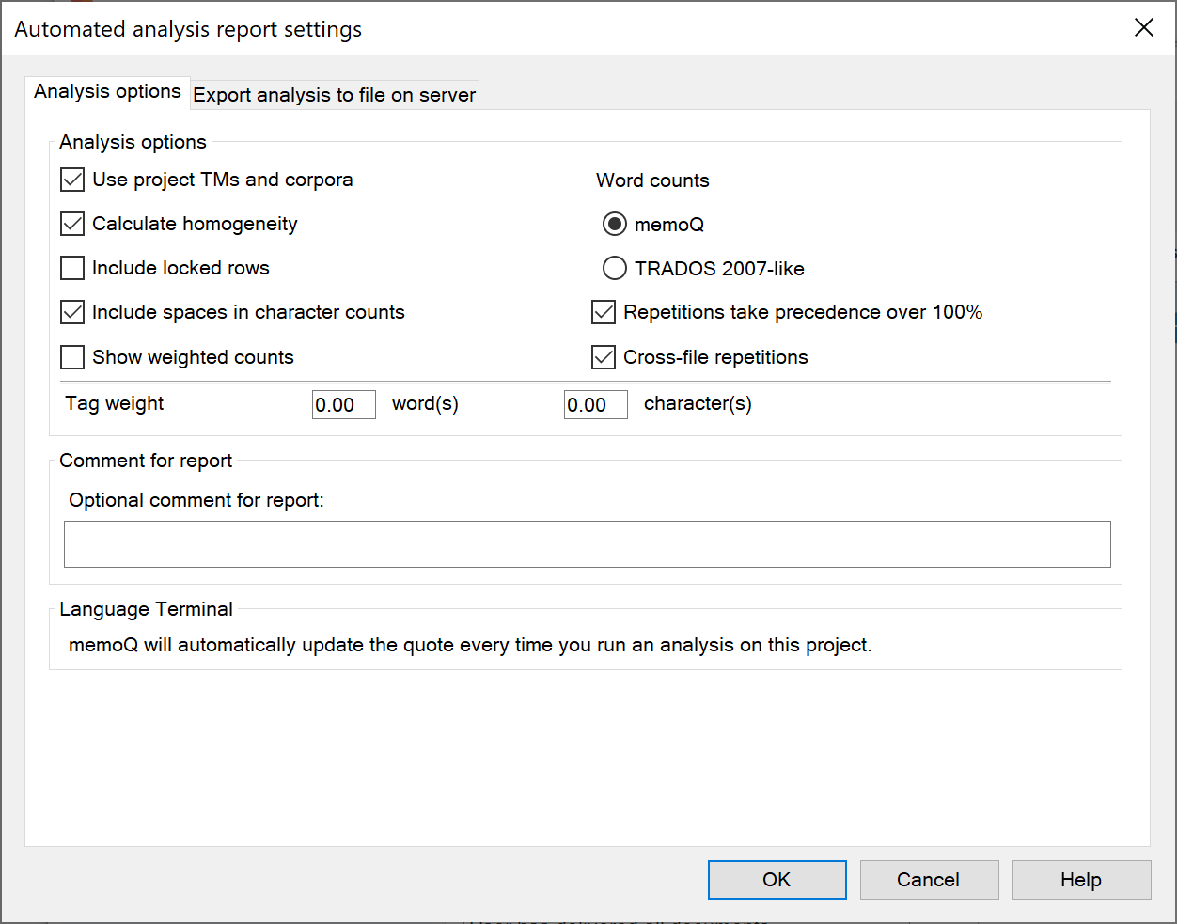

Add Pre-translate as an action, following similar steps.
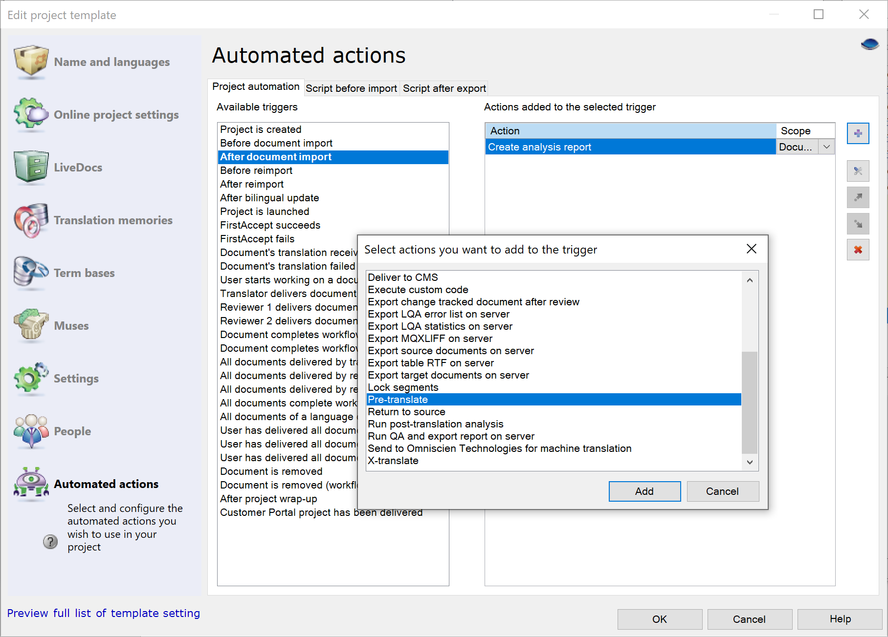

In the Lookup option, choose Good TM or corpus match.
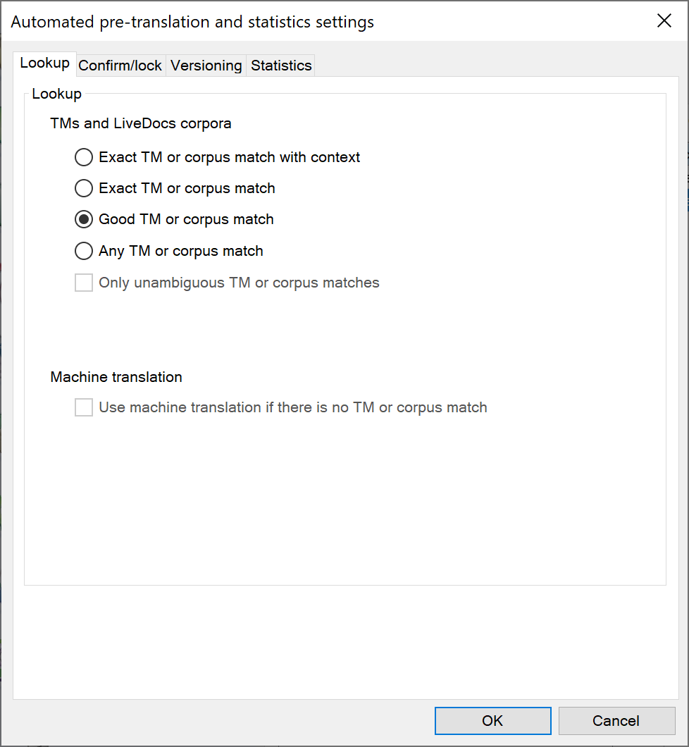

In the Versioning tab, click the boxes to create a version snapshot before and after pre-translation.
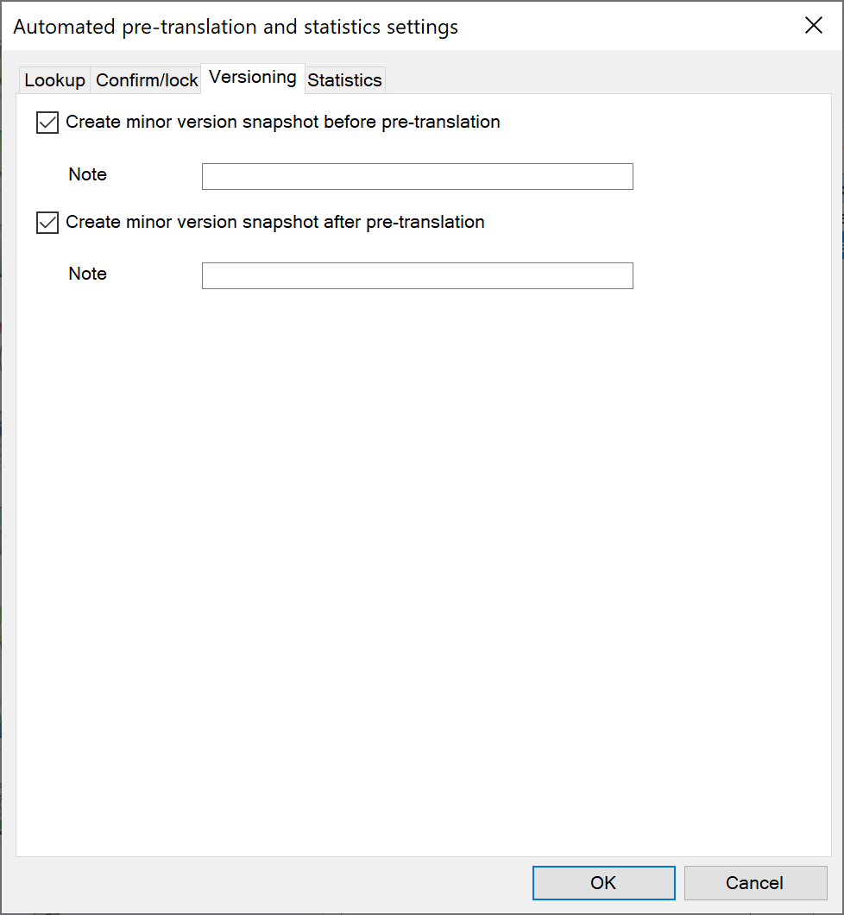

We want to create an RTF table for external review.
Select the Translator delivers translation trigger, and click the + button.
Choose Export table RTF on server.
Change the export path or other options as needed. Click OK.
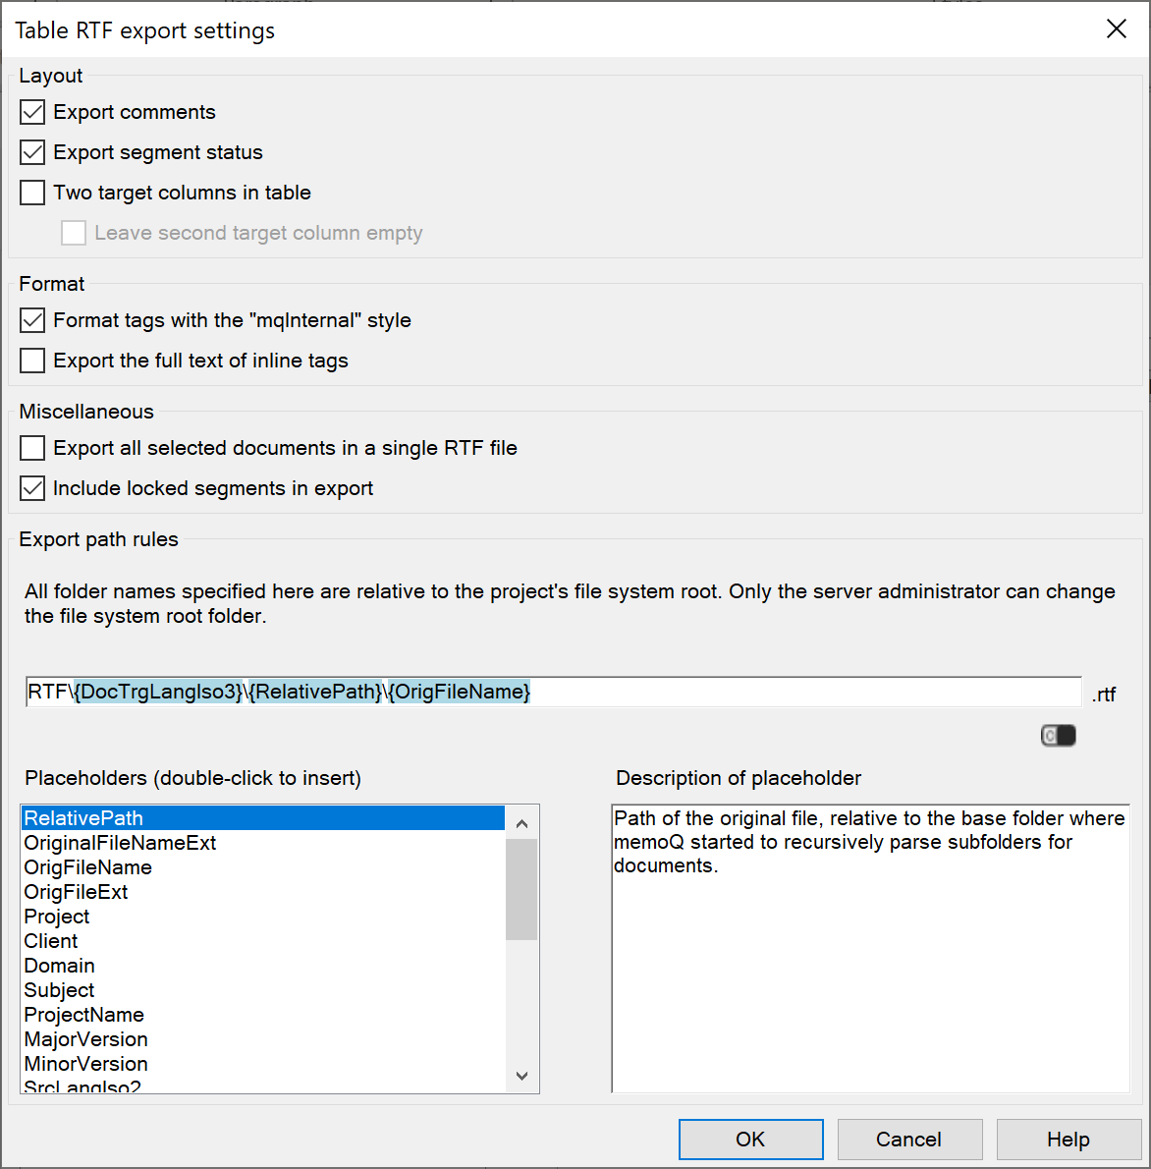

When each document is finished, we want to run a QA to discover any errors.
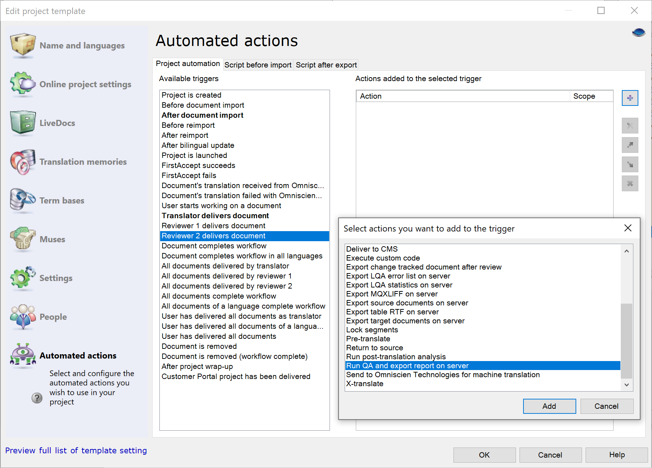

Choose what happens to the QA report. If you need to edit the QA settings, do that outside the project template.
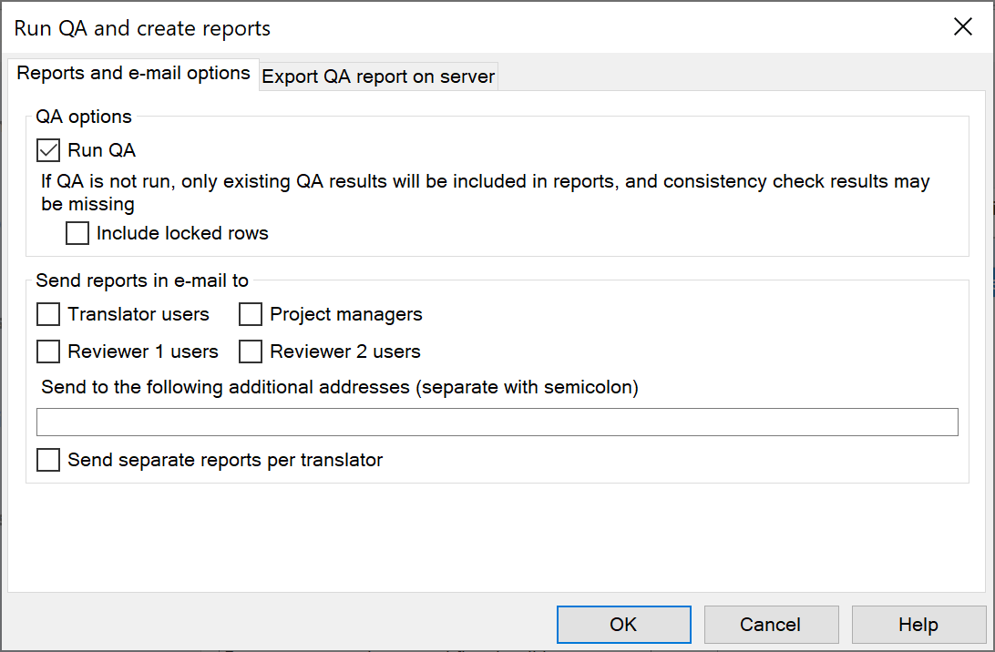

Add more actions to triggers as needed.

